

SOFE 3950U Operating Systems 2021 **Tutorial 4: Jeopardy**

**Group # 14**

**Group Members:**

Ashwin Shanmugam - 100700236

Mihir Patel – 100702168

Esam Uddin – 100711116

Fazal Rahman -- 100724751

‘’

Github Link:

https://github.com/fazemahn/os-tutorial4

We added questions in the following manner:

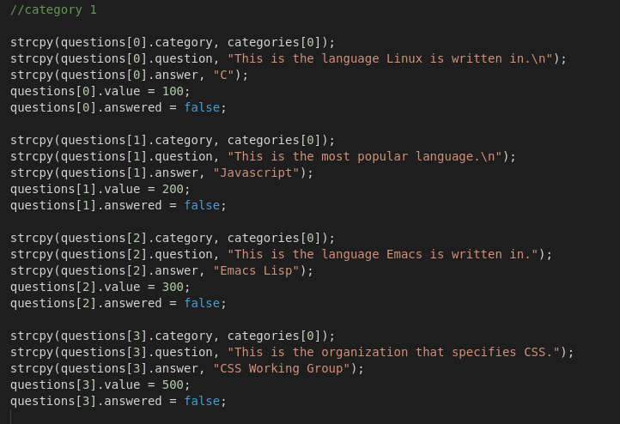

We implemented the following functions:

display_categories();

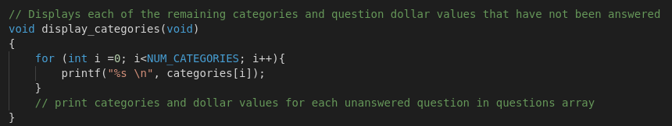

display_question();

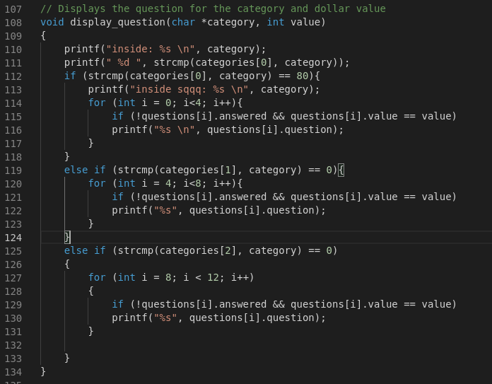

already_answered();

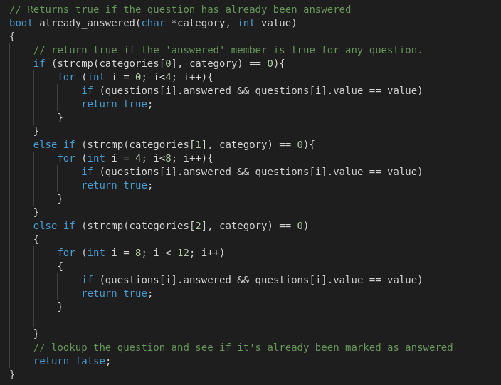

We have implemented all functions.

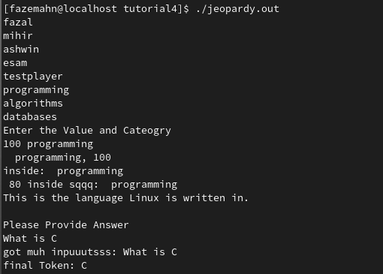

The score update function is not working properly due to type mismatches that are very specific to C.